Reports Menu

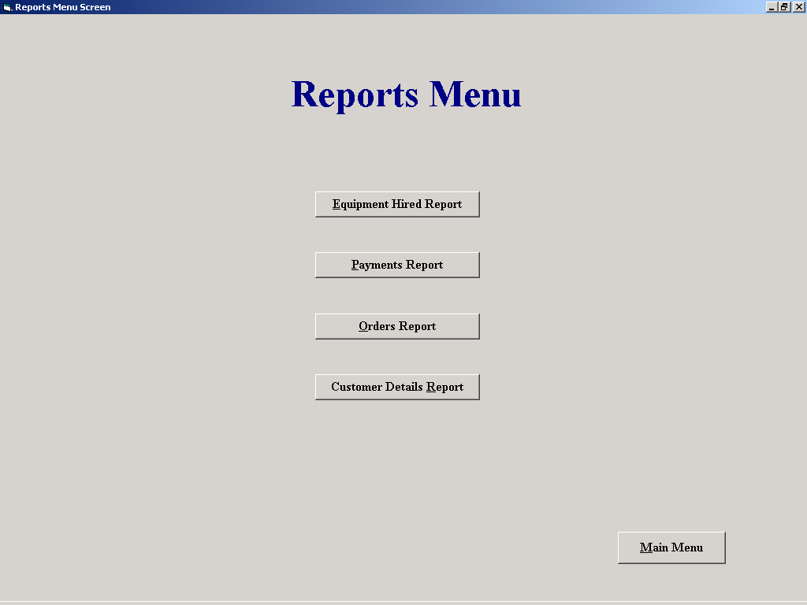

'Purpose This form allows the user to select and open any one of 4
' Report screens

'Student David Hamilton
'StudentID Com2023
'Last Modified 15/3/02

Option Explicit

Private Sub cmdCustDetails_Click()

frmCustReport.Show
Unload Me

End Sub

Private Sub cmdEqptHired_Click()

frmEquipmentHiredReport.Show
Unload Me

End Sub

Private Sub cmdMainMenu_Click()
frmMainMenu.Show
Unload Me
End Sub

Private Sub cmdOrders_Click()

frmOrdersReport.Show
Unload Me

End Sub

Private Sub cmdPayments_Click()

frmPaymentsReport.Show
Unload Me

End Sub

